E-Commerce Customer Behaviour Analysis Project
Author: Sunit Manna
Data Source: Kaggle (Public Dataset)
Tools Used: Python, PostgreSQL (SQL), Excel, Power BI
Project Overview
This project analyses e-commerce customer data to understand customer behavior, spending patterns, and revenue performance. The data was cleaned using Python and Excel, analysed using PostgreSQL, and visualized using Power BI to create an interactive dashboard for business insights.
Project Objectives
- Calculate total customers, total revenue, and average customer spend
- Analyse customer segmentation based on membership type
- Study customer retention and purchase frequency
- Identify top-performing cities
- Analyse customer satisfaction and its impact on revenue
- Visualize customer trends using Power BI dashboard
Tools and Technologies
Python: Data cleaning, preprocessing, and transformation
PostgreSQL (SQL): Data analysis and business query execution
Excel: Data validation and summary analysis
Power BI: Dashboard creation and data visualization
Dashboard Features
- KPI metrics (Total Revenue, Customers, Average Spend, Rating)
- Customer segmentation analysis
- City-wise performance analysis
- Customer satisfaction analysis
- Purchase frequency and retention analysis
- Interactive and user-friendly dashboard

E-commerce Customer Behaviour Analysis Dashboard

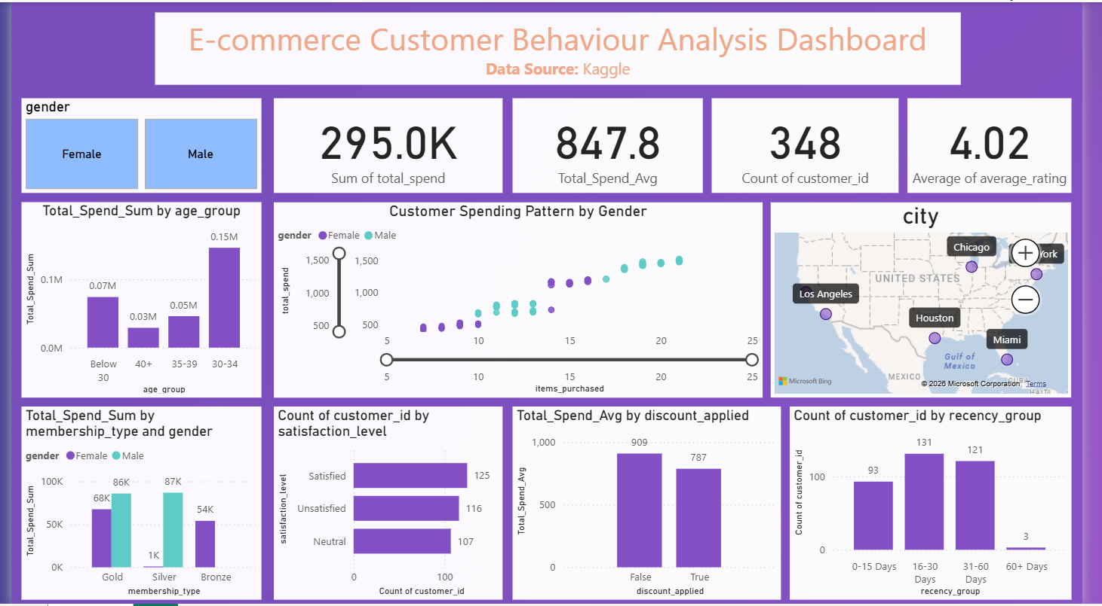

Excel Data Insight (Using SQL Server)
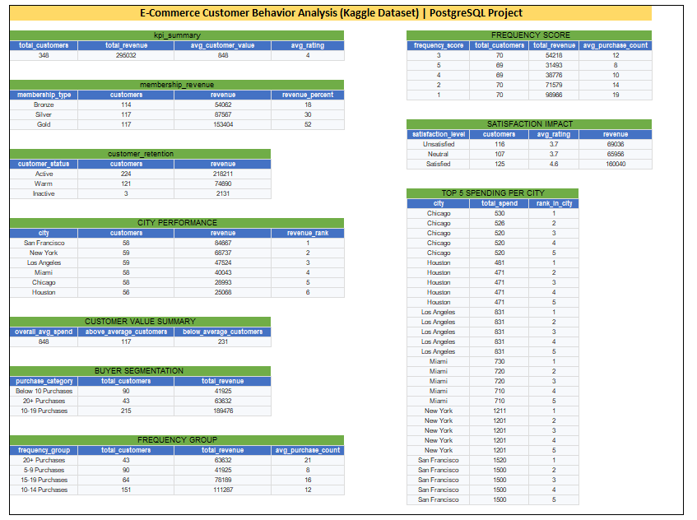

Key Findings
- Total customers: 348
- Total revenue: 295K
- Gold membership customers generated the highest revenue
- Customers aged 30–34 had the highest spending
- New York and San Francisco were top-performing cities
- Higher purchase frequency resulted in higher revenue
Conclusion
This project helped identify high-value customers and important customer trends. The insights can help businesses improve marketing strategies, increase customer retention, and maximize revenue using data-driven decision-making.

